Alenne Jasper Cañete

BSIT – 3rd Year

­

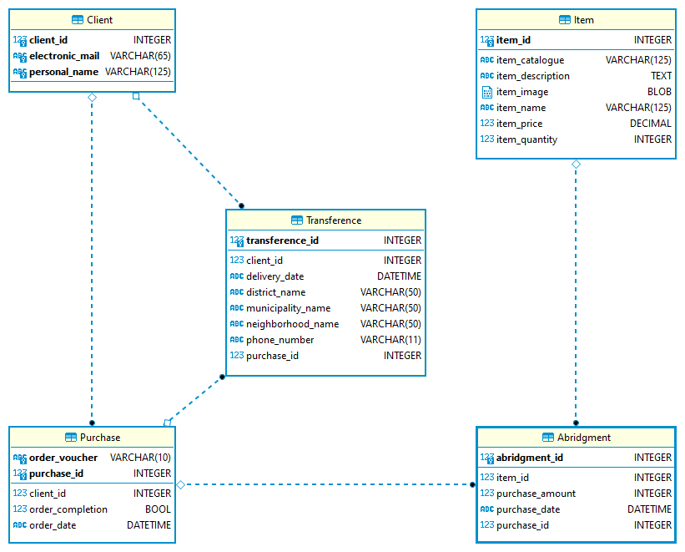

E – Commerce Information System

Entity – Relationship Diagram